**IAM TASKS**

1. Create one IAM user and assign ec2,s3 full access role.

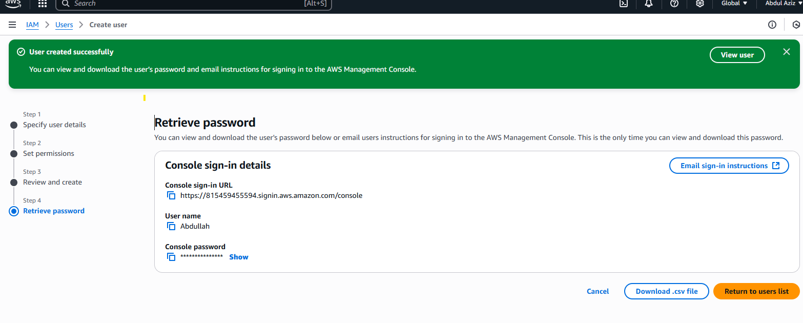

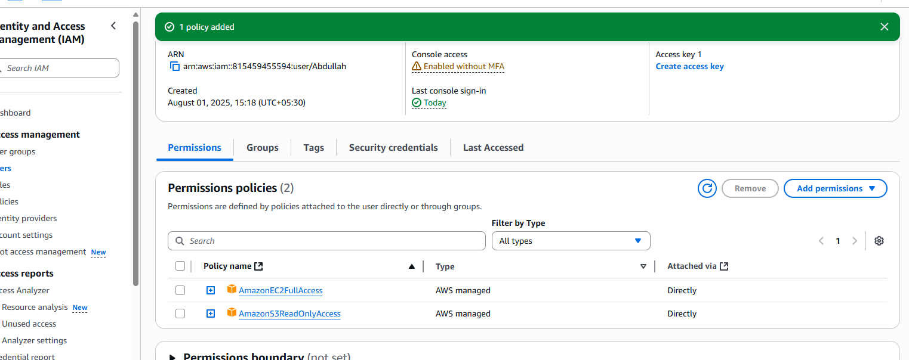

1. Create one Group in IAM and Assign Read access for ec2.

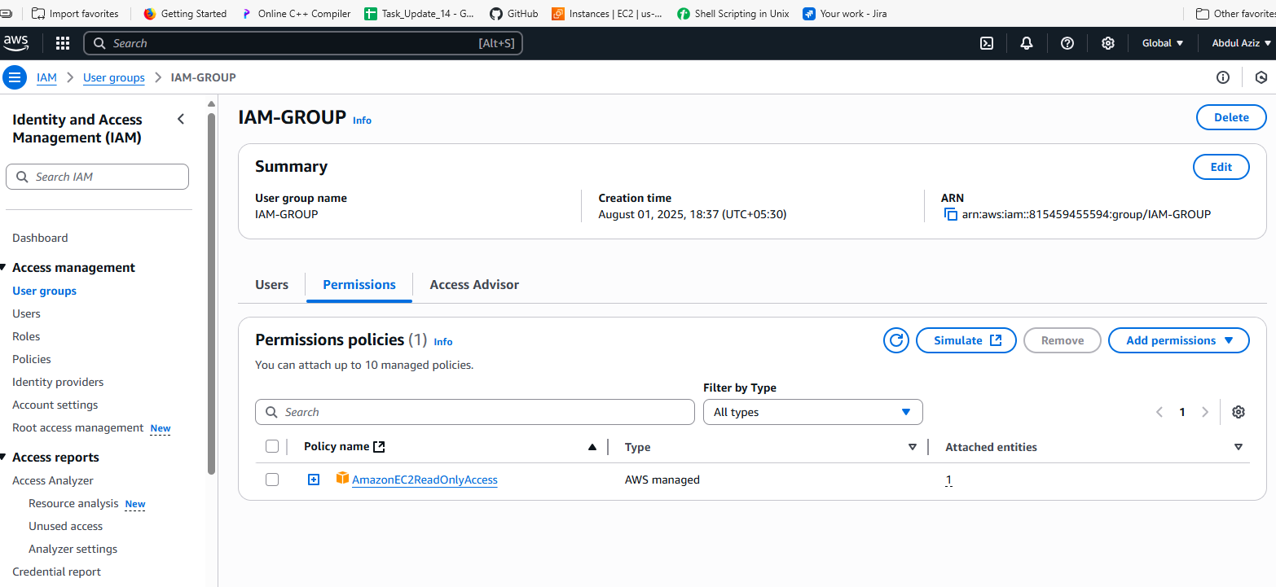

1. Create a new user with name Devops and add to the group created in task2.

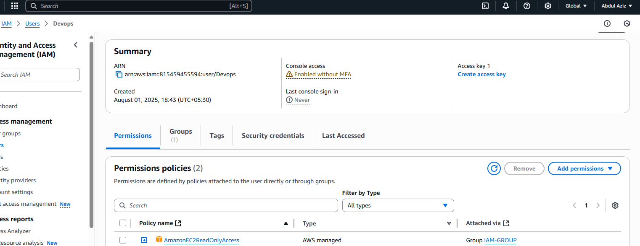

1. Write a bash script to create a IAM user with VPC full access.

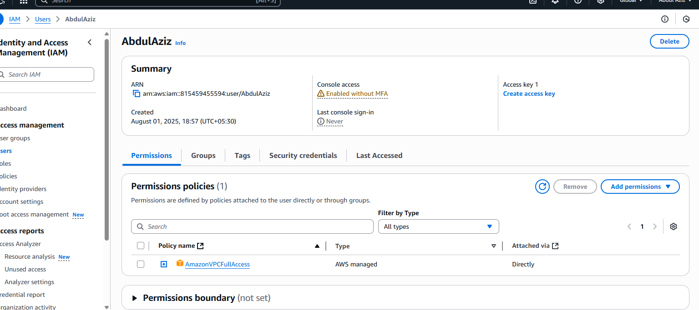

1. Create a IAM policy to access ec2 for a specific user in specific regions only.

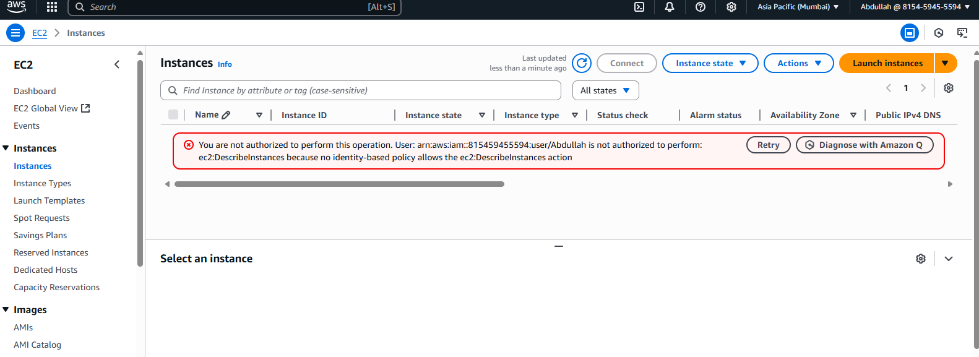

6) We have two accounts Account A and Account B, Account A user should access s3 bucket in Account B. (Collaborate with team member and execute this.Mostly asked in every interview)